University of Regina

ENSE 400/477
Capstone Project

Stride Champions Product Requirements

Authors:
Taylen Jones
Jeremy Cross

Advisors:
Tim Maciag
Craig Gelowitz

Version | Description of Change | Author | Date
1.0 | Initial Document Draft | Taylen, Jeremy
2.0 | Complete Document Revision | Taylen | February.3rd

CONTENTS
1 INTRODUCTION 4
1.1 Purpose 4
1.2 Scope 4
1.3 Main Development Objectives 4
1.4 Secondary Development Objectives 4
1.5 Assumptions and Constraints 4
1.6 Document Overview 5
2 Product Overview

INTRODUCTION

Purpose
The purpose of this project is to provide a new, enjoyable gaming experience in the form of platform fighting. This document will give our project managers and advisors a way to ensure we do not deviate from our path, and give a complete understanding of our goals. This document will include, but not limited to: Requirements, testing models, user interface models, class diagrams, flow charts, user stories, etc.

Scope
1.2.1 In Scope
This project will have two human controlled characters; each with the aim of reducing the other players lives, or “Stocks” to zero. The players will be able to select from one of two available characters, each with their own fighting style and combos.

The playable area will be one of two hand designed arenas. One will be a futuristic inspired platform arena, with the other being a roman coliseum inspired stage.

The game will stress strategy, as well as analyzing and predicting the opponents moves and techniques. The player will also need to be aware of map placement, as falling out of bounds will result in a loss of life.
1.2.2 Out of Scope
This project will not include a single player story mode. Also, the project will be limited to the quality of graphics, assets, playable characters and stages.

Main Development Objectives
- Two Playable Characters
  - Unique fighting styles
  - Unique fighting combos
- Two Main Gameplay Environments
  - Dynamic backgrounds
  - Lighting effects
  - Spawn areas
- Smooth and Enjoyable Combat
- Aesthetics
  - Menu Styles
  - Opening animations
  - Music and Sound effetcs

Secondary Development Objectives
- Controller Support
- Achievements
- Single Player mode
  - Story driven
- In-battle pickups/items
- Improved Visuals
- More Characters
  - Stages

Assumptions and Constraints
Constraints for this project include limited time to complete certain tasks, limited technical skill in the process of learning new programs, technology, money, etc. To lessen the burden of these constraints the project will be developed with free software where available, online tutorials will be used, as well as software that is easy to learn and work with.

1.6 Overview
Stride Champions is a platform fighting game that will allow players to hopefully experience a fresh new take on the genre, while also developing on the foundations built by its predecessors. Players will be able to fight one on one, until either player runs out of stocks.

Scheduling

Started | Finished | Notes
October 11, 2019 | October 11, 2019 | Scrum # 1 - Spending some time learning the technologies is great. However, my advice is that the technologies shouldn't drive the design and development (it should always come after problem and requirement prerequisites) The team is feeling good. My recommendation by next scrum is to focus on drafting an initial requirements document as well as some of the game storyline (who are the characters, what is their world, maybe even some of their backstory, etc.)
October 25, 2019 | October 25, 2019 | Scrum # 2 - Nice user story map. Nice GitHub. Excellent initial character designs. I feel that you folks are on track. Good work!
November 22, 2019 | November 22, 2019 | Faculty Presentations - Craig: What game engine? Have you used it to make anything? There is a lot more to a game than UI. Craig would not be comfortable where you are. Kin-Choong: Have you compared different engines? What are the resources that you need?
January 14, 2020 | January 14, 2020 | Scrum # 3 - Switched technology (from Blender to Adobe Fuse). Still working characters. Would like to see some storyline development by next scrum (if not all of the storyline) as well as some interactivity. Time is going to move pretty quickly!
January 28, 2020 | January 28, 2020 | Good deep dive into the vision and rationale. Good deep dive into the storyline. Take a snapshot (PDF/Excel) of your USM today and upload it to GitHub. Expand your USM and we'll go over this next scrum. Nit-picky things: Spelling and grammar in your slides need work. Project documentation (requirements and the like) need updating - remember, this is a huge chunk of your project grade. We will go over the documentation and progress (working demo) next scrum
January 28, 2020 | Feb 11, 2020 | Started to revise document and info for next scrum (Feb.11^{th).} Need to add USM and Class diagrams still, Class diagrams to be developed after game mechanics started. Fix ToC at some point.

Product Overview and Requirements

Overview
This section of the report will cover our overview and specifications of “Stride Champions”. Description of the specific requirements, analysis of models, and also functions will be discussed. User interface, game flow, and story so far will also be included.

Functional and Non-Functional Requirements

Menus
ID | Requirement
FR1 | Menu format must remain consistent
FR2 | Menus must be easy to navigate
FR3 | Menus must be easy to understand
FR4 | Menus must be visually pleasing, sounding

Combat
ID | Requirement
FR1 | Players must be able to perform basic combat moves
FR2 | Players must be able to move in an 8-direction plane
FR3 | Players must be able to perform combos
FR4 | Players must gain damage on successful landed attacks
FR5 | Players must respawn on defeat (If stocks remain)
FR6 | Players with higher damage percentages must take more recoil on successful hits

Characters
ID | Requirement
FR1 | Characters must be smoothly animated
FR2 | Each character must have unique combos
FR3 | Characters must interact smoothly
FR4 | Models must mesh properly between static and dynamic objects

General
ID | Requirement
FR1 | The system must be user friendly
FR2 | The system must require minimum maintenance
FR3 | The system must have a cost friendly design
FR4 | The system must have smooth FPS rates

Gameplay Display
ID | Requirement
FR1 | HUD must display player damage percentages
FR2 | HUD must display remaining player stocks
FR3 | HUD must display remaining game time
FR4 | HUD must display character names and icons

Models and Charts

System Component Map

Use Case Scenarios and Diagrams

Class and Entity Diagrams

User Stories and Empathy Map

Software and Hardware Requirements
The requirements for the software aspects of this program will include, but not limited to: An easy to use game engine, character design software, animation studio, sound and music studio, various documentation tools. For this project we have used: Unreal Engine 4, Blender (Discontinued), Adobe Fuse, Mixamo, Balsamiq, Stories on Board (Web based), and Microsoft Word.

User Interface and Menus
This section will give an overview and history of the different menus and UI the user will see throughout the game.

The Main Menu is what the user will see upon launch, from here the various other menus and game modes can be accessed.

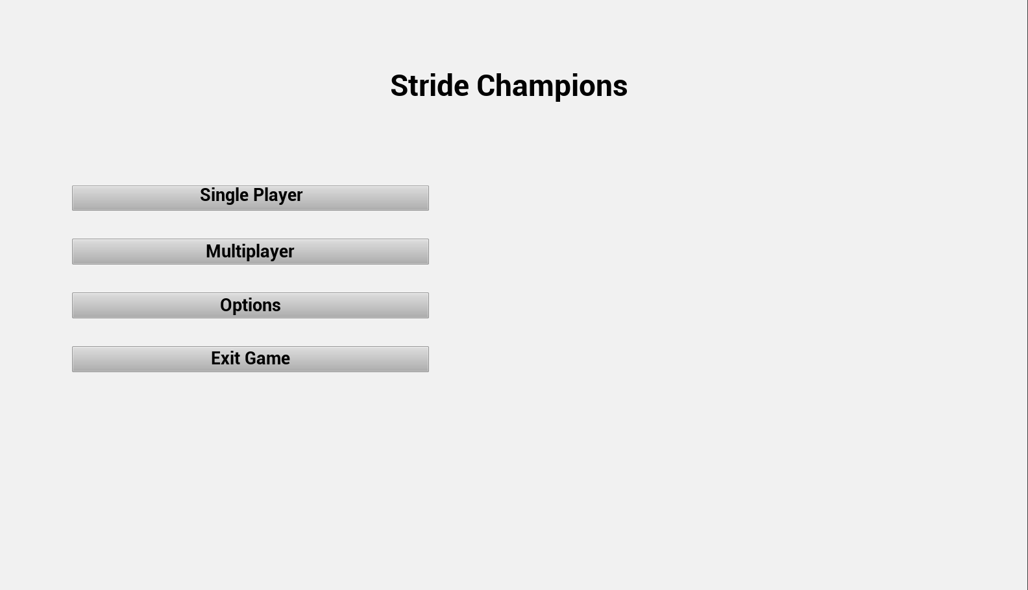

Figure Main Menu (MK 1)

Pause Menu:
This menu will let the player pause gameplay, while also being able to change settings and exit gameplay.

Character Select Screen:
This menu will allow the players to select which characters they will be using for gameplay.

Stage Selection Screen:
This menu will allow player one to select the stage that they will be fighting on.

Options Menu:
This menu will allow the player to change certain options surrounding gameplay.

